Step 1 : Search the Service RDS in AWS and Click Database. On Top Right You see the Create new database option to Create a new instance of DB.

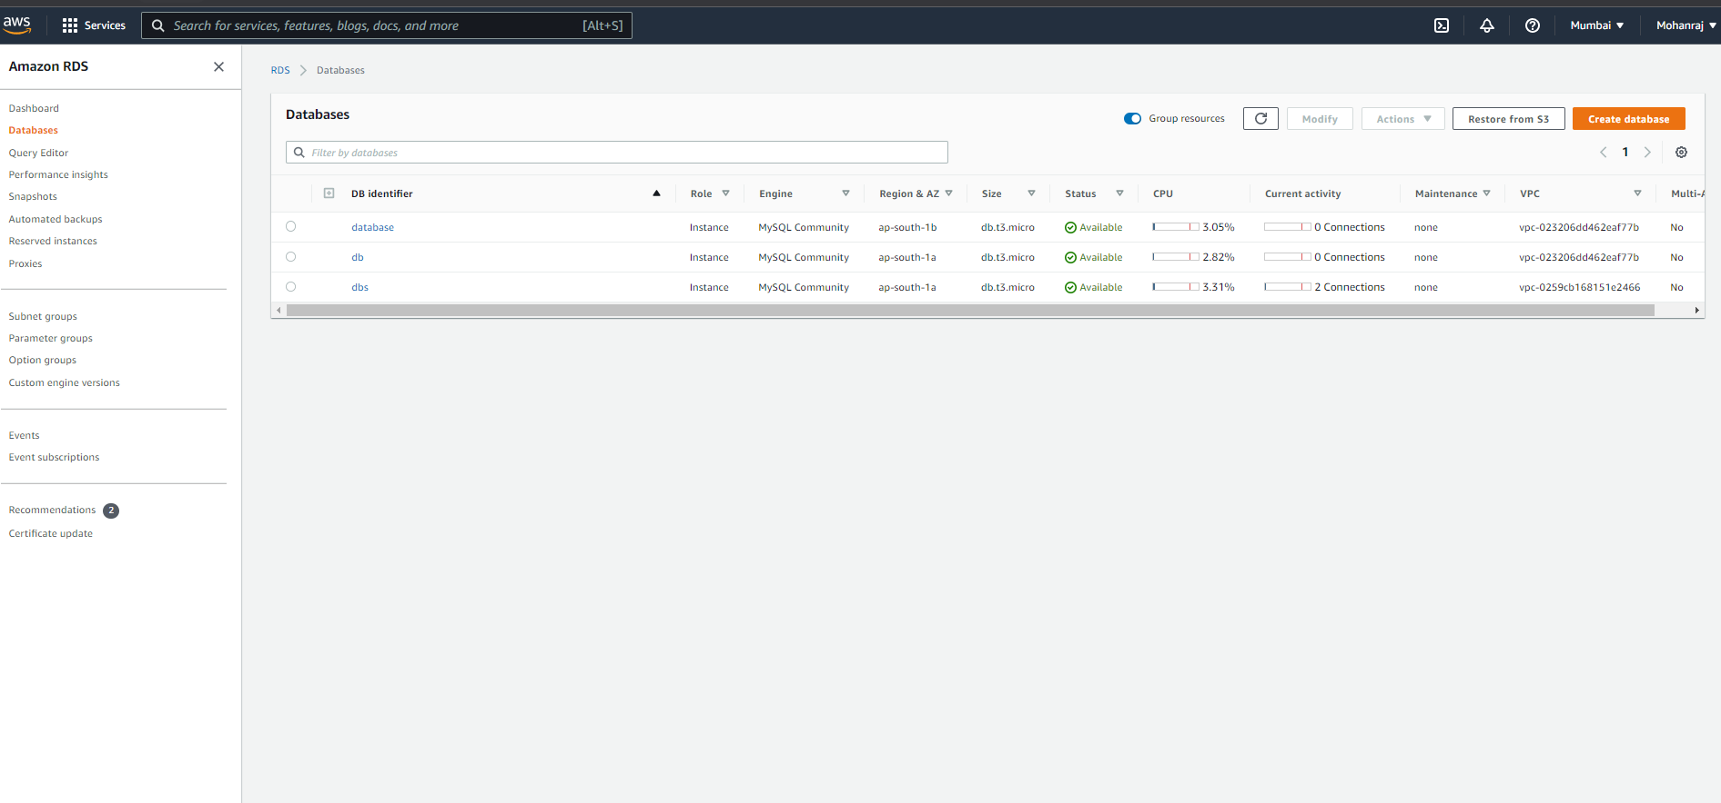

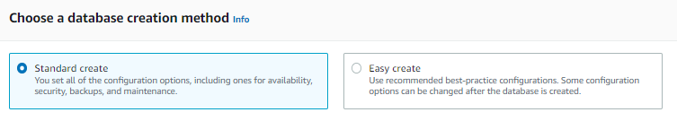Step 2: Choose the database creation Method.

Step 3: Select the Engine Options. 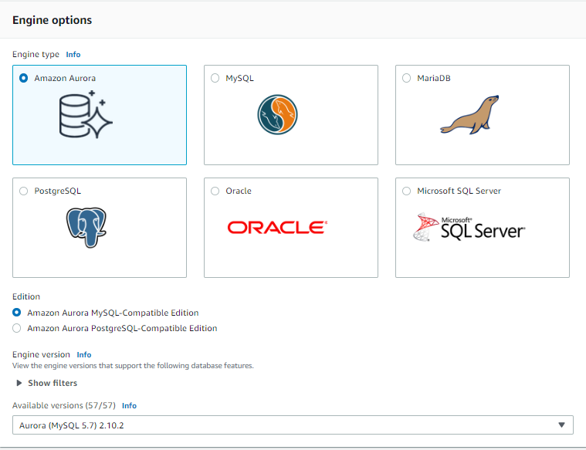

Step 4 : Choose the Template

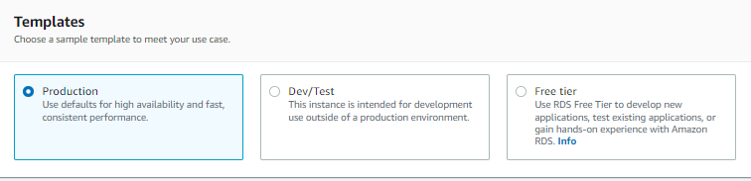

Step 5 : Choose the Settings and Credential setting.

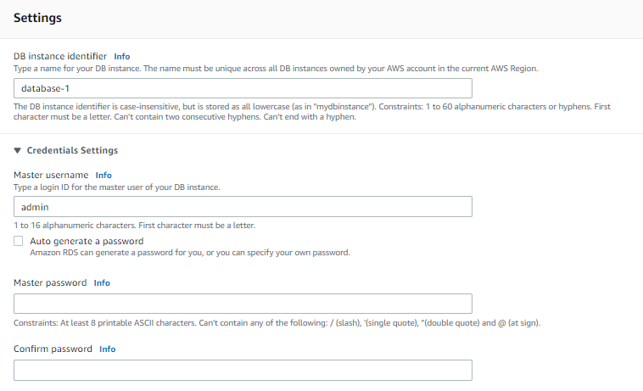Step 6 : Choose the Instance Configuration.

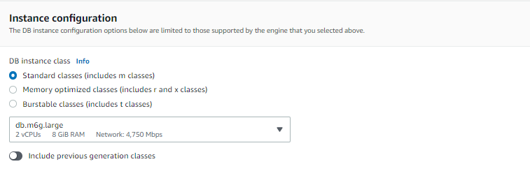

Step 7: Specific the storage how much you want.

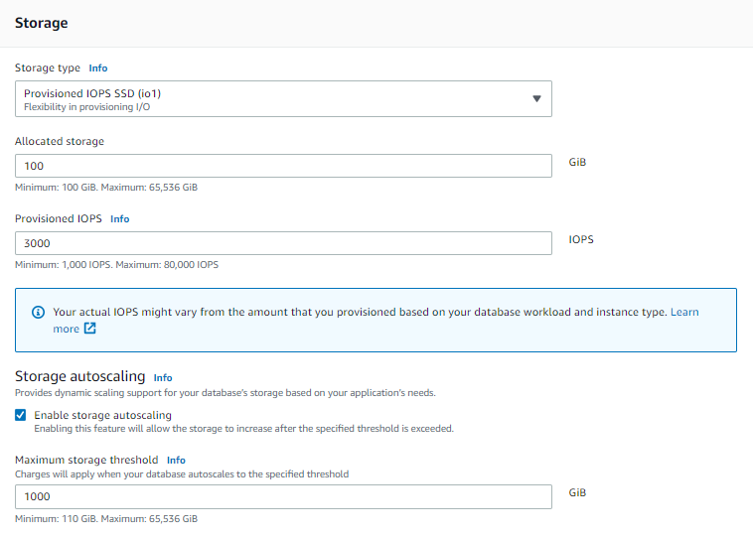

Step 8: Choose the connectivity Either local machine or Ec2 Resource.

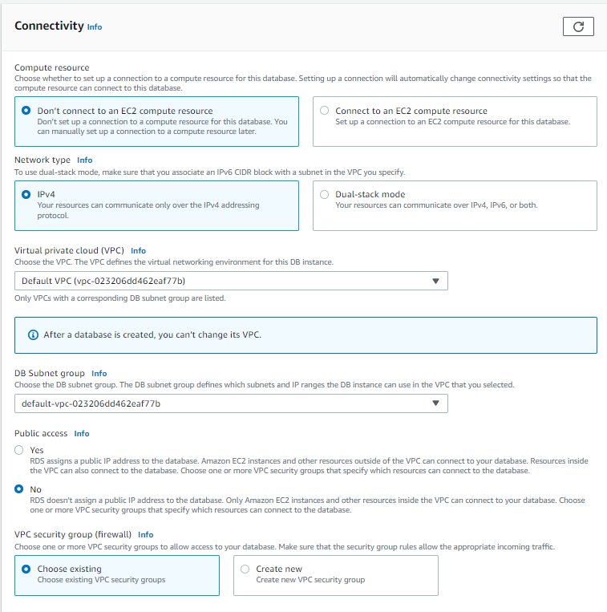

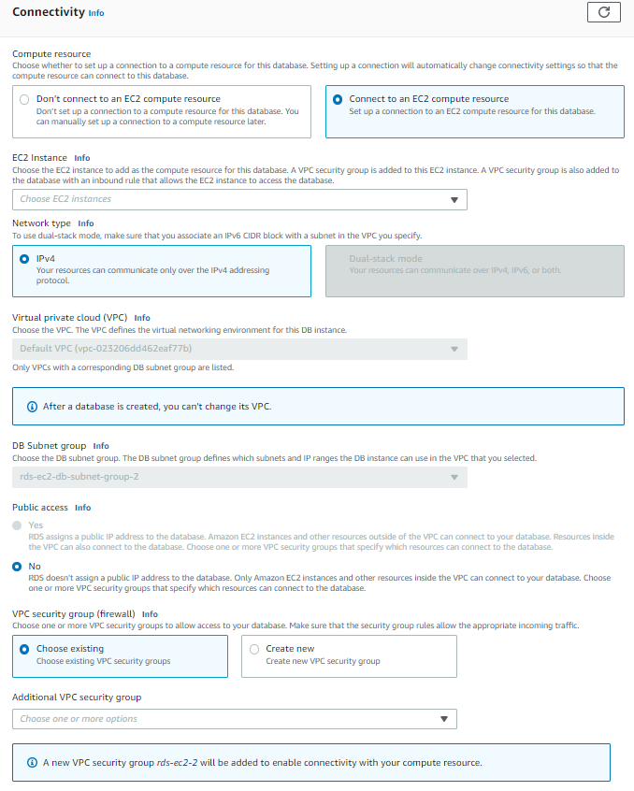

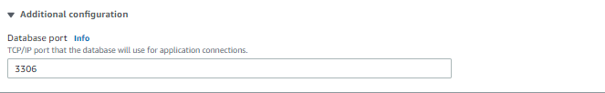Step 9: Choose select the DB port when you want to connect with Local Machine.

Step 10: select the additional configuration.

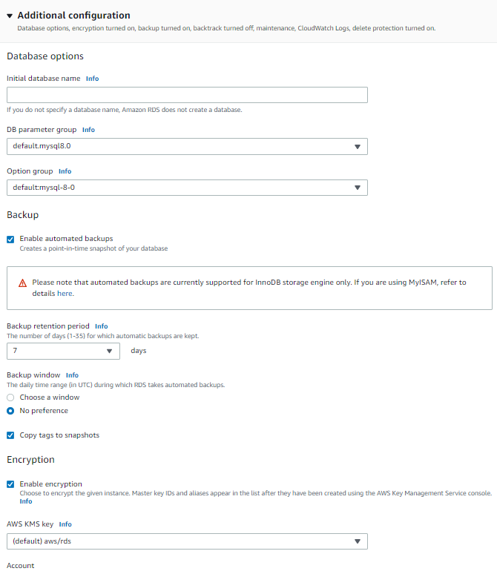

Step 11. Click on Create Database at the end.

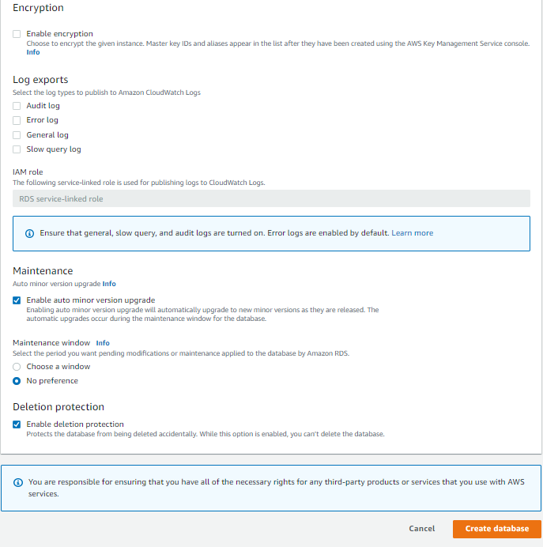

Step 12 : After the DB is Created open the instance.

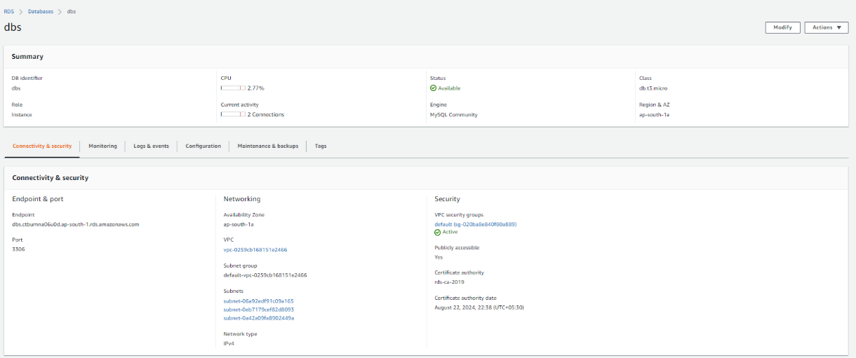

Step 13 : Click the Edit inbound option.

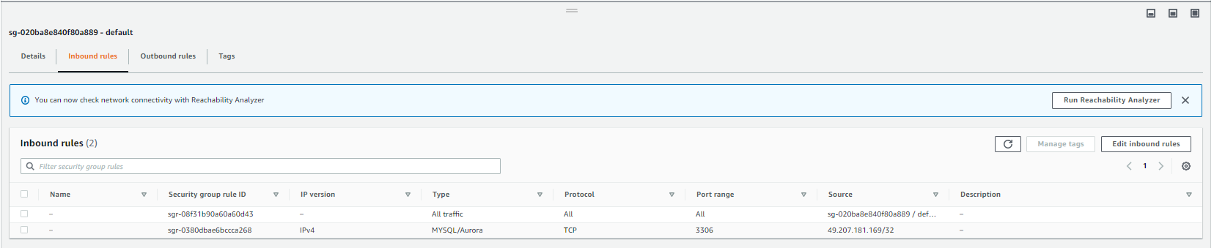

Step 14 : add another rule.



Step 15 : Open MYSQL WorkBench and Click the Plus icon.

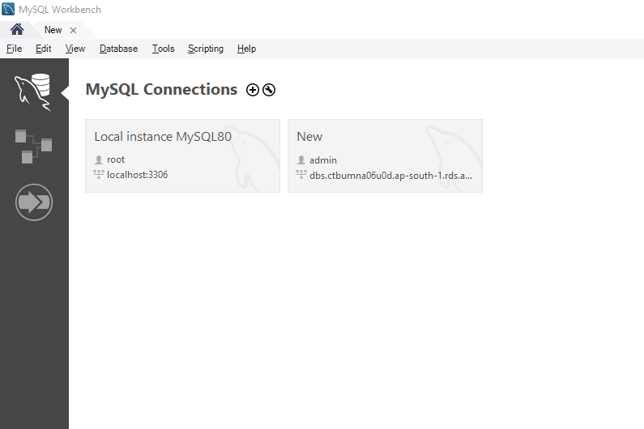

Step 16 : New setup connection window is opened.

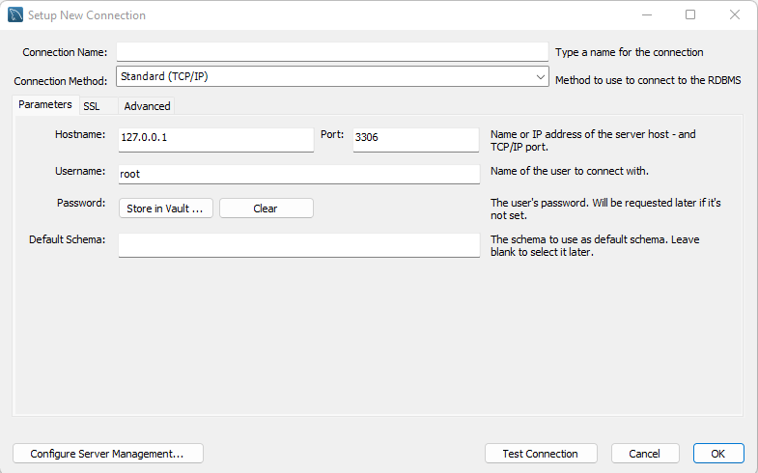

Step 17 : Enter the Endpoint of DB instance has a HostName. Enter the username password that you mentioned while creating a DB instance. Click test connection and Ok.